**Module Six Project**

**Two Optimization Problems:**

**A Transshipment Problem**

**&**

**A Risk Minimizing Problem**

Mohit Ravindra Kamble

College of Professional Studies – Northeastern University

ALY - 6050: Introduction to Enterprise Analytics

Prof. Zhi (Richard) He

March 29, 2024



1. **Overview:**

This assignment includes two optimization tasks: a transshipment problem for Rockhill Shipping & Transport Company (RSTC) and a risk minimization problem for investment allocation. The transshipment problem involves optimizing shipping routes for waste disposal, while the risk minimization problem focuses on minimizing risk in investment allocation to achieve a 20% return.

1. **Analysis & Findings:**

**Part - 1:** Transshipment Problem

For addressing the transshipment problem, my initial approach involved leveraging Excel's Solver add-in to formulate a linear programming model aimed at minimizing overall shipping expenses while meeting supply and demand constraints. *The optimized solution, focusing on direct shipping from plants to disposal sites, revealed a weekly shipping cost totaling $3,400.*

|  |
| --- |
|  |

However, I also considered the possibility of transshipping loads through intermediate plants and disposal sites. By expanding the decision variables to include plant-to-plant and site-to-site routes, and solving this more complex transportation problem, *I found a much lower minimum cost of $920 per week.* Notably, the total quantity transshipped remained equal to the 300 barrels per week supply.

**#Note:** *Please excuse the indentation; it is kept this way to view the below output clearly.*

|  |
| --- |
|  |

Next, I explored a scenario where transshipment is permitted, allowing for waste drop-offs and pickups at intermediate plants and disposal sites. The costs of shipping between plants and disposal sites were given. Using Excel's Solver, I determined the optimal solution that minimizes total shipping costs while meeting supply and demand constraints.

|  |
| --- |
|  |

**#Note:** *Please excuse the indentation; it is kept this way to view the below output clearly.*

|  |
| --- |
|  |

This solution involves transferring waste between plants before shipping it from the plants to disposal sites, eliminating direct waste shipments to disposal sites. The process is based on the optimal solution for direct shipping.

**Summary for Part - 1:**

If the capacity of each disposal site is increased by 10 barrels per week, the optimal solution for direct shipping remains the same, with a *total weekly shipping cost of $3,390.* ***However, for the transshipment case, the optimal solution changes slightly, with the total weekly shipping cost remaining at $920.***

**Part - 2:** Risk Minimization Problem

To solve the risk minimization problem, I first set up a linear programming model in Excel to minimize the portfolio variance (risk) while achieving a target return of 20%. The model allocated the $500,000 investment across the six asset types as follows:

|  |
| --- |
|  |

The minimized portfolio variance (risk) was 0.0078, and the expected return was 20%, meeting the target.

|  |
| --- |
|  |

Next, I analyzed how the portfolio variance changes for different target returns, ranging from 7% to 25%. I used Excel's Solver to find the optimal portfolio allocations and minimize the variances for each target return. The results were plotted on a graph, with the x-axis representing the variance and the y-axis representing the expected return.

|  |
| --- |
|  |

The graph showed an increasing trend, with higher target returns leading to higher minimized variances (risk). This pattern suggests that there is a trade-off between risk and return, where higher expected returns can only be achieved by accepting higher levels of risk. *The relationship between risk and return appeared to be non-linear, with the variance increasing at a faster rate for higher target returns.*

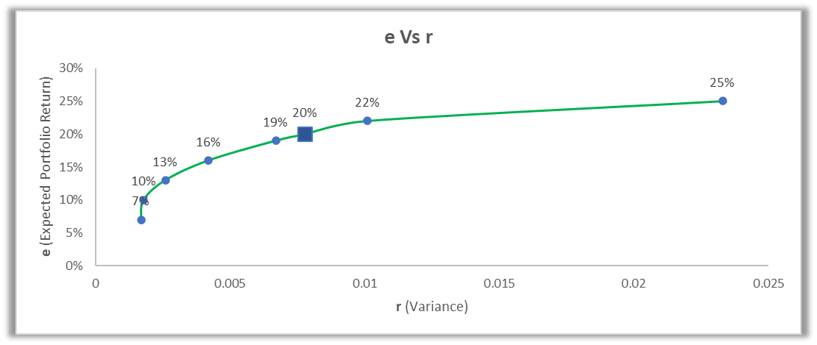

1. **Conclusion:**

To summarize everything, For the transshipment problem, I determined the optimal shipping routes and costs for two scenarios: direct shipping (total weekly cost of $3,400) and transshipment using intermediate points (lower total weekly cost of $920 but more complex routing). Increasing disposal site capacities by 10 barrels per week slightly lowered the direct shipping cost to $3,390 ***but did not change the $920 transshipment cost.***

For the risk minimization problem, I allocated a $500,000 investment across assets to *achieve a 20% return while minimizing variance (0.0078)*. Analyzing different target *returns from 7-25% showed an increasing risk-return tradeoff, with variance rising non-linearly as target returns increased.*

In order to balance risks and costs, attain the desired returns and service levels, and ensure supply chain logistics and investment portfolio management are executed with precision, these optimization issues underscore the significance of meticulous planning and analysis.

1. **Citation(s):**

* Problems with Transshipment and Nonlinear Programming Models

- *Module 6 Lab video*